**Katz School FAQ**

**What degrees does the Katz school offer? Which degrees are available online?**

|  |  |  |  |
| --- | --- | --- | --- |
| **Academic Programs** | **Abbreviations** | **STEM and Health** | **Formats Available** |
| Artificial Intelligence | AI | STEM (MS) | On-Campus |
| Data Analytics and Visualization | DAV | STEM (MS) | On-Campus |
| Biotechnology Management and Entrepreneurship | BME or BTM | STEM (MS) | On-Campus/Online |
| Cybersecurity | Cyber | STEM (MS) | On-Campus/Online |
| Digital Marketing and Media | DMM | STEM (MS) | On-Campus/Online |
| Mathematics | MAT | STEM (MA) | On-Campus |
| Physics | PHY | STEM (MA/PHD | On-Campus |
| Occupational Therapy | OTD | Health (Doctorate) | On-Campus |
| Physician Assistant Studies | PAS | Health (MS) | On-Campus |
| Speech-Language Pathology | SLP | Health (MS) | On-Campus/Online |

**How do I:**

See my schedule of classes?

Location of classes?

Tuition due?

How do I pay tuition?

How do I tell there are holds on my account?

**Go to Student Dashboard**

Students can find most of the answers to their questions on their Student Dashboard (schedule of classes, location of classrooms, tuition due, holds on accounts, etc.).

* Insidetrack.yu.edu
* Student
* Undergraduate/Graduate (it’s the same button)
* Frequently Used Links
* Student Dashboard

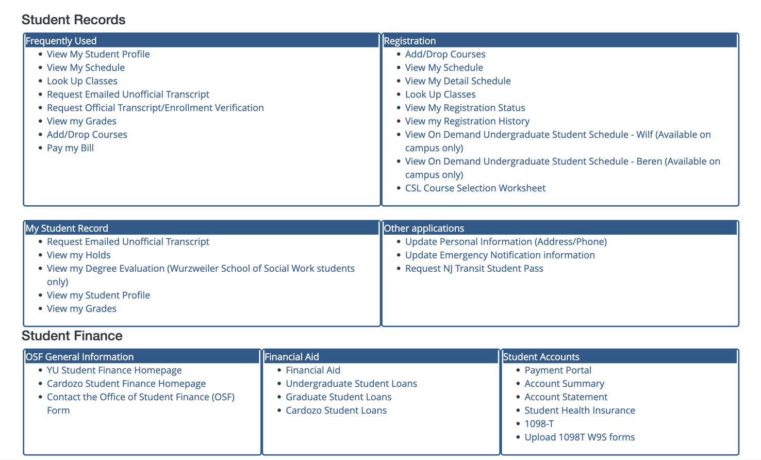

**I’m having technical problems registering. Email, including screenshot of error to:**

[**Katzgraduateregistrar@yu.edu**](mailto:Katzgraduateregistrar@yu.edu)**.**

**When is the school administrative offices closed? Staff Holiday Schedule (when office is closed)**

<https://www.yu.edu/sites/default/files/inline-files/Holiday%20Schedule%202023_0.pdf>

**Graduate Academic Calendar (important semester dates)**

<https://www.yu.edu/registrar/grad-calendar>

**How much is my tuition or I have questions about tuition and fees?**

Any questions about tuition, please send them to the tuition page. <https://www.yu.edu/osf/tuition-fees/graduate>.

**How to Register for classes: (STEM Courses)**

[Registration Instructions and CRNs (STEM - Spring 2023) - STEM 1.pdf](https://yuad-my.sharepoint.com/:b:/g/personal/john_vivolo_yu_edu/EaEUJpMFbJtKr9DStbbOmUABxqbh_j4lsrtMq7h9nqKLnQ?e=Md4bOR) (SAMPLE language)

**Academic Advisement (STEM)**

STEM Students should contact their program directors regarding the courses they should take (academic advisement).

**Program Director List (STEM)**

|  |  |  |
| --- | --- | --- |
| **Name** | **Program Director** | **Email** |
| Artificial Intelligence | Pablo Roldan | [pablo.roldan@yu.edu](mailto:pablo.roldan@yu.edu) |
| Data Analytics and Visualization | Andy Catlin | andrew.catlin@yu.edu |
| Biotechnology Management and Entrepreneurship | Rana Khan | [rana.khan@yu.edu](mailto:rana.khan@yu.edu) |
| Cybersecurity | Sivan Tehila | [sivan.tehila@yu.edu](mailto:sivan.tehila@yu.edu) |
| Digital Marketing and Media | Joseph Panzarella | [joseph.panzarella@yu.edu](mailto:joseph.panzarella@yu.edu) |
| Mathematics | Marian Gidea | marian.gidea@yu.edu |
| Physics | Fredy Zypman | Fredy.zypman@yu.edu |

**Does YU have a Career Center? I need interview and resume help:** <https://www.yu.edu/sgc.> CC Rafael Reyes.

**Registrar:** I can’t register for classes. Need to drop a course. Can’t add a course.

**Solution:**

* Look up student bannerID and check for Holds. <https://banner.oci.yu.edu/StudentSelfService/ssb/termSelection>
* Solutions to account holds are below:

**Student Account Holds**

If you have a hold on your account, you will not be allowed to register for your courses.

* + For Financial Holds: Contact [accounts@yu.edu](mailto:accounts@yu.edu). Include your full name and Banner ID number (starts with 800). You may also call the accounts office directly at: 646-892-6260.
  + For questions regarding financial aid/loans, please email: [studentaid@yu.edu](mailto:studentaid@yu.edu) and/or call 646-592-6250.
  + For Missing Transcripts and/or diploma Holds: Contact [gradschool@yu.edu](mailto:gradschool@yu.edu)

**School ID: How to Obtain Your Student ID**

Send a passport-style photo of yourself from the chest up, with a solid color background,

to yucardpix@yu.edu with your:

* Legal name
* YU ID number
* School (Katz School)
* Academic Program
* Campus (Beren, Resnick or Wilf)

**Pick Up:** At Beren main security office or our office (if we have their School IDs).

**Pick-up Your ID**

Students can pick up their YU ID at the security offices at:

• Beren Campus: 50 East 34 Street, NY, NY 10016 (Brookdale Residence Hall)

• Wilf Campus: 521 West 185th Street, NY, NY 10033

**How do I take a leave of absence:** 120 day leave from a program.

<https://www.yu.edu/sites/default/files/inline-files/Leave%20of%20Absence_Dec_2020.pdf.>

CC program director.

**I need to change my name:**

Have them fill out this form and email it to katzgraduateregistrar@yu.edu

<https://www.yu.edu/sites/default/files/inline-files/YU_Change%20of%20Name%20Form%202022_1.pdf>

**Student Life**

Students want to start a club, organization or has any other questions about non-academic student/campus life: Rafael Reyes at [rafael.reyes@yu.edu](mailto:rafael.reyes@yu.edu). Any question about student life, clubs, life in the city, housing, or anything else non-academic related (out-side of classroom)

**Student** **Email**

If a student says they didn't receive their YU email, ask them to check their spam folder. It does take 48 hours after they pay their deposit before that email arrives.

If they still don't receive the email on how to access their YU email have them follow these instructions:

YU email is also a gmail account although it ends with a YU student email extension. The login for yu email, banner, and canvas is all the same login. First, you need to know your banner ID number.

* You can get your BannerID # with this link: <https://banner.oci.yu.edu/ssb/yumisweb.fetchad>. Put in your last name and SS number.
* This will give you your BannerID number and your Active Banner ID (your username).
* Once you have your BannerID, your default password is the first letter of your last name and the last four digits of your social security number.
* You use this same username and password to get into banner, your email (through gmail), and Canvas (your class work), and any other YU system for students.

If you continue having difficulty, please call YU helpdesk with your BannerID and explain the problem. (646)592-4357 or (800)337-2975.

**I don’t see my course in Canvas (instructure.yu.edu).**

* Courses are available 3 business days before the start of the semester.
* If it is not published, see if they can reach out to the faculty and/or program director about publishing the course asap.

**Students ask about registering for graduation.**

## **To Apply for 2023 Degree Conferral:**

* Complete the [application for graduation](https://www.yu.edu/sites/default/files/inline-files/Application%20for%20Graduate%20School%20Graduation%208421.pdf) and return your completed application to [Katzgraduateregistrar@yu.edu](mailto:Katzgraduateregistrar@yu.edu).
* Students who expect to graduate in January, May or August 2023 must apply by January 30th, 2023 in order to have their degree conferred and to be considered for graduation.
* There is a $150 graduation application fee. Once your application has been processed by the Registrar’s Office, the graduation fee is payable online by check, credit card or bank wire transfer at <https://insidetrack.yu.edu/>.
* **To Participate in the Katz School's 2023 Graduation Ceremony:** 
  + The Katz School's 2023 Graduation Ceremony will occur on Monday, May 15th. Any student who graduates in January, May or August 2023 can walk in the 2023 Graduation Ceremony.
  + Keep an eye on your email for details about the 2023 Graduation Ceremony from the [Katz@yu.edu](mailto:Katz@yu.edu).

**Student wishes to defer to next semester (Fall 2023).** Defer is when a student decides to start their program the next semester.

* Forward email to [katzgrad@yu.edu](mailto:katzgrad@yu.edu) (Jackie, Shayna, Xavier, Jared).

**I’m having trouble with my login or other student technical issues.** Email [helpdesk@yu.edu](mailto:helpdesk@yu.edu) or call: (646)592-4357 or (800)337-2975.

**Scholarship Question**

* Student scholarships are not awarded in one semester. They are distributed over multiple semesters.
* Email Nancy Barr ([nancy.barr@yu.edu](mailto:nancy.barr@yu.edu)) with further questions.

**Student wants to be added to a course or drop a course.**

* ***STOP!*** Students cannot be added to a course. Students can only enter a course through registration.
* After the add date has passed, a student must use the manual form to add a course. [Registration Add-Drop_Fillable_1 (4).pdf.](https://yuad-my.sharepoint.com/:b:/g/personal/john_vivolo_yu_edu/EQGfp9ibnPdKujhObU_N1PEBhe-y7_R9J4ro1FLSQKkEEQ)
* A student may drop a course using the fillable form as well if they are unable to do

**Academic Writing and Language Support**

* Writing Tutor: Sofia Binioris at [sofia.binioris@yu.edu](mailto:sofia.binioris@yu.edu)
* ESL Tutor: Paul Shively at [paul.shively@yu.edu](mailto:paul.shively@yu.edu).
* Virtual Speech Clinic (SLP): [Virtual Speech Clinic Survey](https://forms.office.com/Pages/ResponsePage.aspx?id=tA7HBCaPB0iZNOAuiSZq0Jf3w4HQeuRCsu5-nhjE64ZURFZWSzk5OUkzTjVEUEI5NTA3NzEwWlRISyQlQCN0PWcu)
  + Contact: Andrew Christler: [andrew.christler@yu.edu](mailto:andrew.christler@yu.edu)